Phase - 3 Practice Project

2. Displaying User Feedback

* **Output**

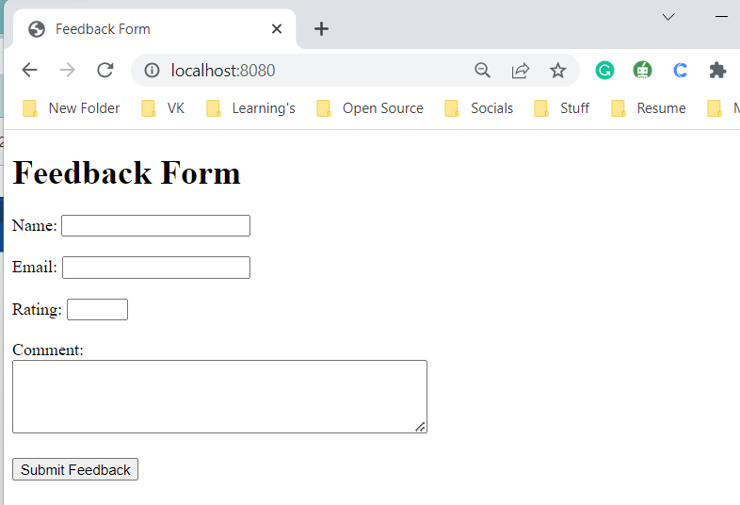

* **Adding User Feedback 1**

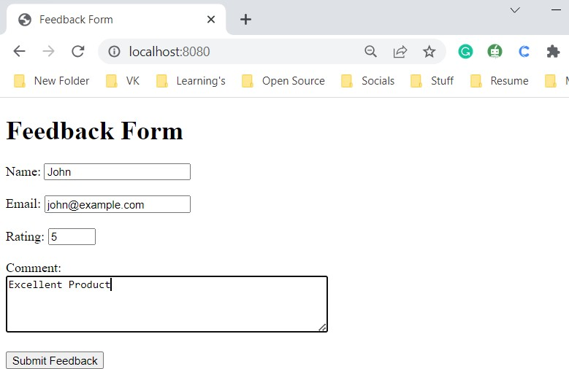

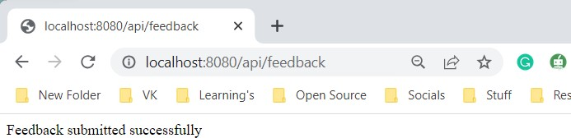

* **Database Output**

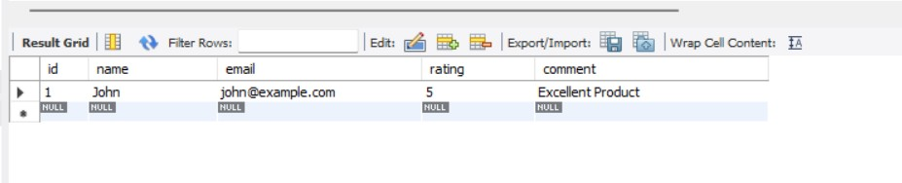

* **Adding User Feedback 2**

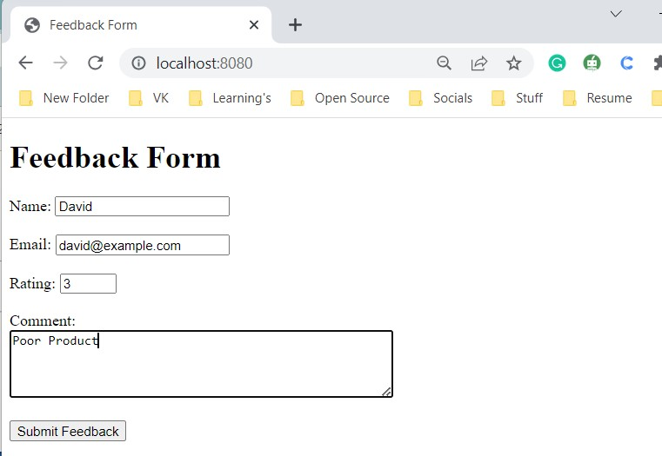

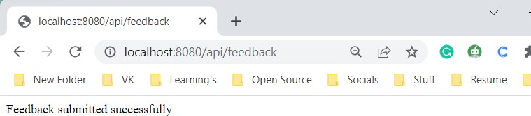

* **Database Output**

